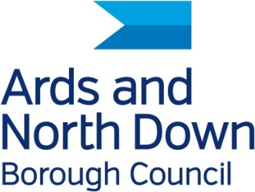

**Media release 18 June 2025**

**Young Creators Bring Museum to Life in New Children’s Book**

North Down Museum is thrilled to announce a delightful collaboration with local author and illustrator Ellan Rankin and the young artists of Bright Sparks Montessori Pre-School, resulting in a beautifully imaginative children’s book *Max’s Magical Visit to the Museum* that brings the museum’s rich history to life.

The project, funded by the Northern Ireland Museums Council, invited the children to help shape a new story designed to introduce young readers to the key areas of history on display at the museum. Under Ellan Rankin’s guidance, the children contributed to the creative process by making decisions about the story’s characters and providing colourful textures that have been incorporated into the book’s illustrations.

The pupils also took on the role of mini-detectives during a visit to the museum, eagerly exploring the galleries in search of historical treasures to help inform the story.

To celebrate their involvement, a special presentation ceremony was held at North Down Museum on Tuesday 17 June, where The Deputy Mayor of Ards and North Down, Councillor Vicky Moore, presented each child with a copy of the finished book and a certificate marking their contribution.

Speaking about the initiative, the Deputy Mayor said:

*“This project is a shining example of how creativity and education can come together to inspire the museum’s youngest visitors. The children should be incredibly proud of their work, this book will be a lasting legacy of their imagination and enthusiasm.”*

Ruth Verner, Education and Outreach Officer at North Down Museum, commented:

*“It’s been a joy to watch the children engage so enthusiastically with our museum and see their ideas come to life in Ellan’s artwork. This collaboration highlights how museums can be vibrant spaces for learning and creativity.”*

*Max’s Magical Visit to the Museum* will be available in the Story Corner of the museum’s Little Historians Gallery, and copies will also be available soon at the following libraries across the Borough: Bangor, Comber, Donaghadee, Holywood, Newtownards, Portaferry, and the Bangor Mobile Library.

For more information on North Down Museum, visit: [www.andculture.org.uk](http://www.andculture.org.uk)

**//ends//**

**For media enquiries contact Stacy Eakin at:**

[**stacy.eakin@ardsandnorthdown.gov.uk**](mailto:olive.broderick@ardsandnorthdown.gov.uk)